Crop Production & Yield Analysis
Data Analytics Capstone Project
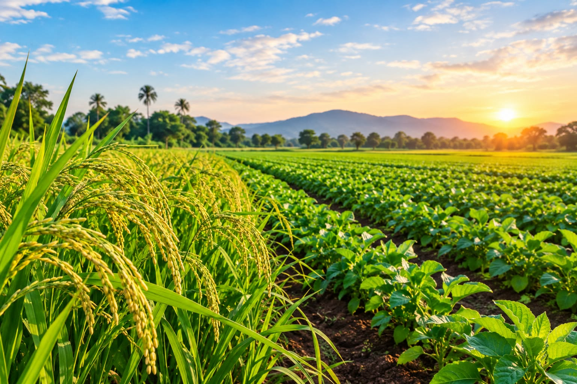

1.Introduction

Agriculture plays a significant role in the Indian economy by providing food, employment, and raw materials for various industries. Crop production is influenced by several factors, including geographical location, cultivated land area, crop type, and agricultural season. Understanding these factors is important for analysing agricultural performance and identifying differences in crop yield across states and seasons.
The Crop Production & Yield Analysis project aims to analyse agricultural data to understand crop production patterns across different states, crops, and seasons. The project focuses on comparing total crop production, identifying crops with higher production, examining variations in yield, and understanding how agricultural production differs across regions and years.
This project uses various data analytics tools and technologies, including Microsoft Excel, MySQL, Python, and Power BI. Excel is used for initial data inspection and preparation, MySQL is used to query and analyse data, Python is used for exploratory data analysis and visualisation, and Power BI is used to develop an interactive dashboard that presents the findings clearly.

2.Scope of the Project
This project focuses on analysing crop production and yield across different states, crops, agricultural seasons, and years. The analysis will help identify differences in production levels, compare crop yields, and understand agricultural patterns.

The project includes data cleaning and preparation using Microsoft Excel, database analysis using MySQL, exploratory data analysis using Python, and interactive dashboard development using Power BI.

The scope is limited to the information available in the selected dataset. The findings will be used for educational purposes to demonstrate how data analytics tools can support agricultural analysis and decision-making.

3.Problem Statement
Agricultural production varies across different states, crops, and growing seasons. Understanding these variations is important for identifying production patterns and evaluating crop yield. However, raw agricultural data can be difficult to understand without proper cleaning, analysis, and visualisation.
This project aims to analyse crop production data using data analytics tools and techniques. It focuses on comparing production across states, identifying crops with higher production, examining seasonal differences, and analysing crop yield. The project will use Excel for data preparation, MySQL for querying data, Python for exploratory data analysis, and Power BI for creating an interactive dashboard.
The findings will help identify important patterns and provide meaningful insights into agricultural production. The project also demonstrates how data analytics can transform raw data into useful information for decision-making.

4.Project Objectives
The main objectives of the Crop Production & Yield Analysis project are:
- To collect and organise crop production data for analysis.
- To clean and prepare the dataset by identifying missing values, duplicate records, and data inconsistencies.
- To analyse crop production across different states, crops, and agricultural seasons using SQL.
- To explore agricultural data using Python and create meaningful visualisations.
- To compare crop yield and identify production patterns across states and years.
- To develop an interactive Power BI dashboard to present key performance indicators and findings.
- To provide data-driven insights and recommendations based on the analysis

5.Business Questions
The following business questions will be addressed through this project:
- Which states have the highest total crop production?
- Which crops contribute the most to total agricultural production?
- Which agricultural season has the highest crop production?
- Which states have the highest average crop yield?
- How does crop production change across different years?
- Which crops have the highest yield per hectare?
- What patterns can be identified by comparing crop production across states and seasons?

6.Data Dictionary
The data dictionary describes the columns used in the Crop Production & Yield Analysis dataset. It explains the meaning and data type of each column to help understand the dataset and perform accurate analysis.

Column Name | Description | Data Type
State_Name | Name of the where the crop is produced. | Text
District_Name | Name of the district where the crop was cultivated. | Text
Crop | Name of the crop being cultivated. | Text
Season | Agriculture season  during which the crop is grown. | Text
Crop_Year | Year in which the crop was produced. | Whole Number
Area | Area of land used for crop cultivation. | Decimal Number
Production | Total quantity of crop produced. | Decimal Number

7.Dataset Source & License
Dataset Source: Indian crop production dataset containing state-wise and district-wise agricultural information.
Dataset Description: The dataset contains 15,000 rows of crop production records with information about states, districts, crop years, seasons, crops, cultivated area, and production.
Licence: To be confirmed from the original dataset source.

8.Conclusion
The Crop Production & Yield Analysis project aims to analyse agricultural data to understand crop production and yield variations across different states, crops, seasons, and years. By using tools such as Microsoft Excel, MySQL, Python, and Power BI, the project will transform raw data into meaningful information.
The analysis will help identify production patterns, compare crop yields, and present important findings through visualisations and an interactive dashboard. This project will also provide practical experience in data cleaning, SQL querying, exploratory data analysis, and data visualisation.
Overall, the project demonstrates how data analytics techniques can be applied to agricultural data to support better understanding and informed decision-making.

